1. In chrome browser type install git
2. Select 1.5 Getting started-installing git
3. Download for windows/linux based on your OS
4. Goto command prompt
5. Type git and click enter, commands will be displayed
6. Next crate one new folder and set the path of the folder in the cmd promt.
7. In the cmd type **git init**.
8. Next type **git status**.
9. Create one text file in the note pad.
10. Create one .py file
11. Type git status in git status, so you can see 2 files.
12. Next type **git commit -m “commiting copy and sample”**

If you get an error like below

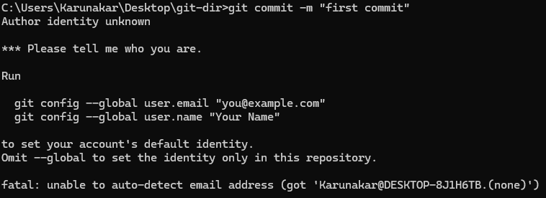

1. In such case use the below commands

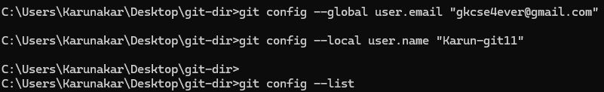

1. Type **git commit -m “print and sample”**



1. Go to github
2. Create new repository with the folder name(git-dir) you created

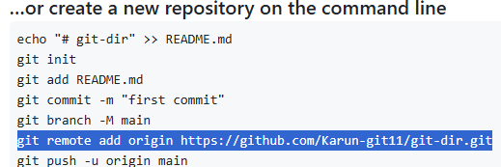

1. Type the above highlighted command in cmd.
2. Type **git branch**



1. Type **git push -u origin master**
2. If not authenticated need to complete authentication

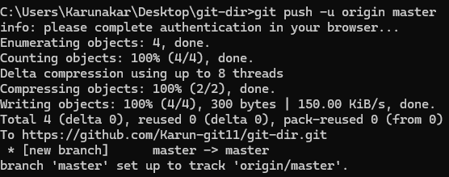

1. Now go to github and refresh the page then you will see commit files.
2. Next create branch: type in cmd **git checkout -b “karun1”**

Note: check out is used to jump between branches



1. Type **git branch**

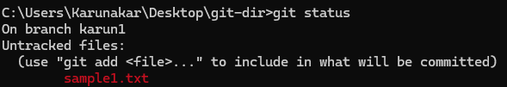

1. Check with **git branch**
2. Type **git add sample1.txt**
3. Type **git status**
4. Next type git commit -m “committing sample1 to karun1”

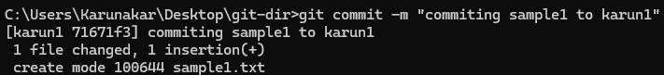

1. Type in cmd the below command

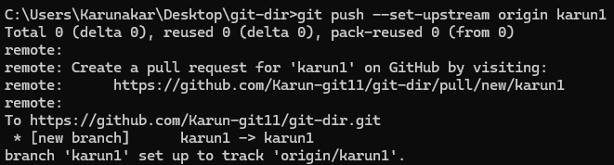

1. Refresh the git repository page

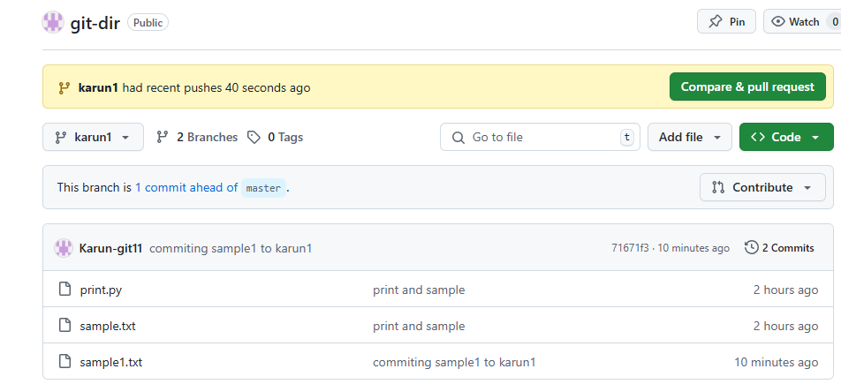

1. Next if you want to merge the file of karun1 into master file
2. Click on compare and pull request on git page
3. Write some to text to merge the file and click on create pull request.

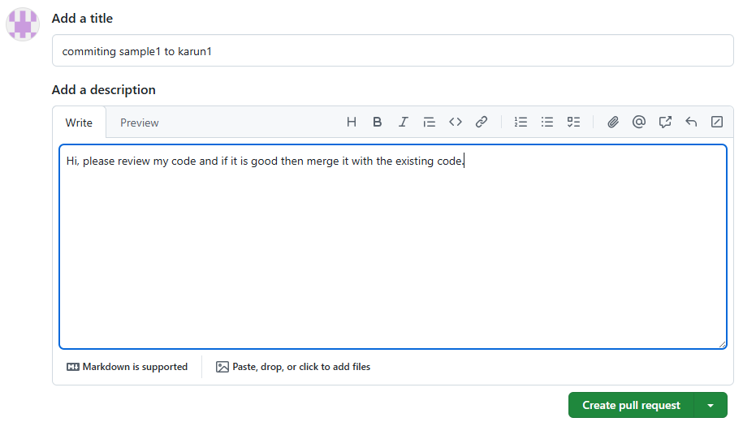

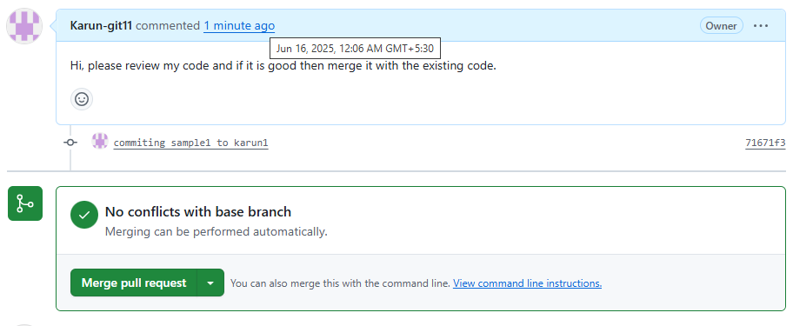

1. Click on merge pull request
2. Click on confirm merge.
3. Now the branch file is merged into master file.

